**Task-08 Screenshots**

**Q1.Create a new Excel Workbook.**

**code:**

**package task_8;**

import java.io.FileNotFoundException;

import java.io.FileOutputStream;

import java.io.IOException;

import org.apache.poi.xssf.usermodel.XSSFWorkbook;

public class FileOperation {

public static void main(String[] args) throws IOException {

// Creating an object of file

try (XSSFWorkbook wb = new XSSFWorkbook()) {

try {

// Create a excel file with specified location

FileOutputStream file=new FileOutputStream("C:\\Users\\ELCOT\\eclipse-workspace\\guvi_tasks\\src\\task_8\\Task-08 Excel.xlsx");

System.out.println("File workbook successfully created");

wb.write(file);

} catch (FileNotFoundException e) {

e.printStackTrace();

}

}

}

}

**code and output:**

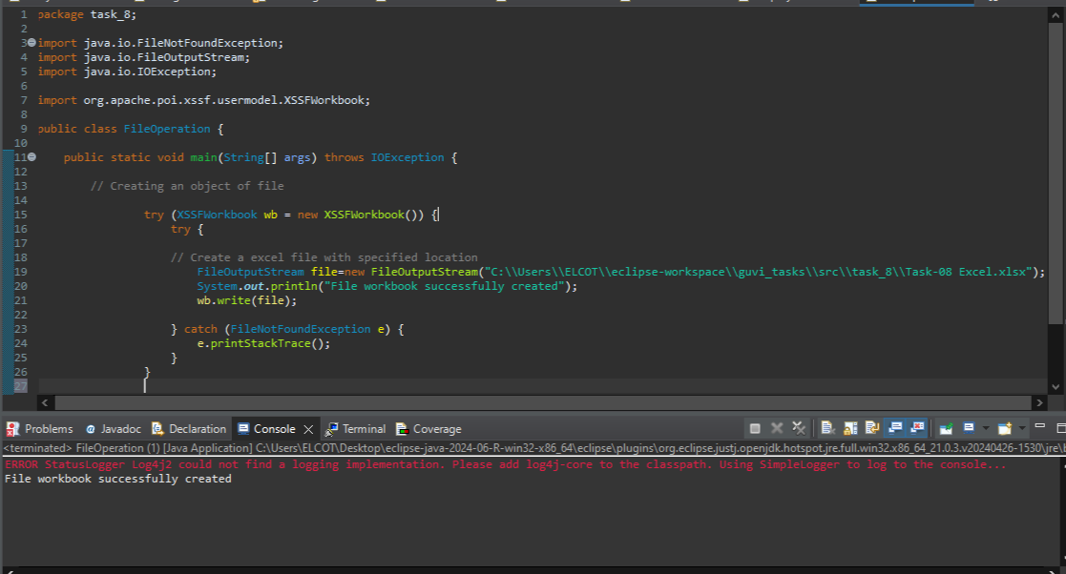

**Q2.Create a new Sheet with the name "Sheet1".**

**code:**

package task_8;

import java.io.FileNotFoundException;

import java.io.FileOutputStream;

import java.io.IOException;

import org.apache.poi.xssf.usermodel.XSSFSheet;

import org.apache.poi.xssf.usermodel.XSSFWorkbook;

public class FileOperation {

public static void main(String[] args) throws IOException {

// Creating an object of file

try (XSSFWorkbook wb = new XSSFWorkbook()) {

try {

// Create a excel file with specified location

FileOutputStream file=new FileOutputStream("C:\\Users\\ELCOT\\eclipse-workspace\\guvi_tasks\\src\\task_8\\Task-08 Excel.xlsx");

System.out.println("File workbook successfully created");

// Create a Sheet in excel name of "Sheet1"

XSSFSheet sheet1=wb.createSheet("Sheet1");

System.out.println("Sheet has been created successfully");

wb.write(file);

}

catch (FileNotFoundException e) {

e.printStackTrace();

}

}

}

}

**code and output:**

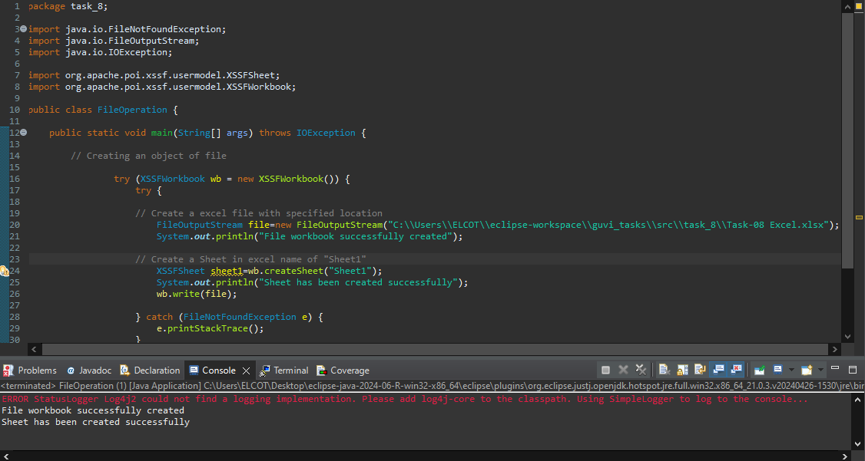

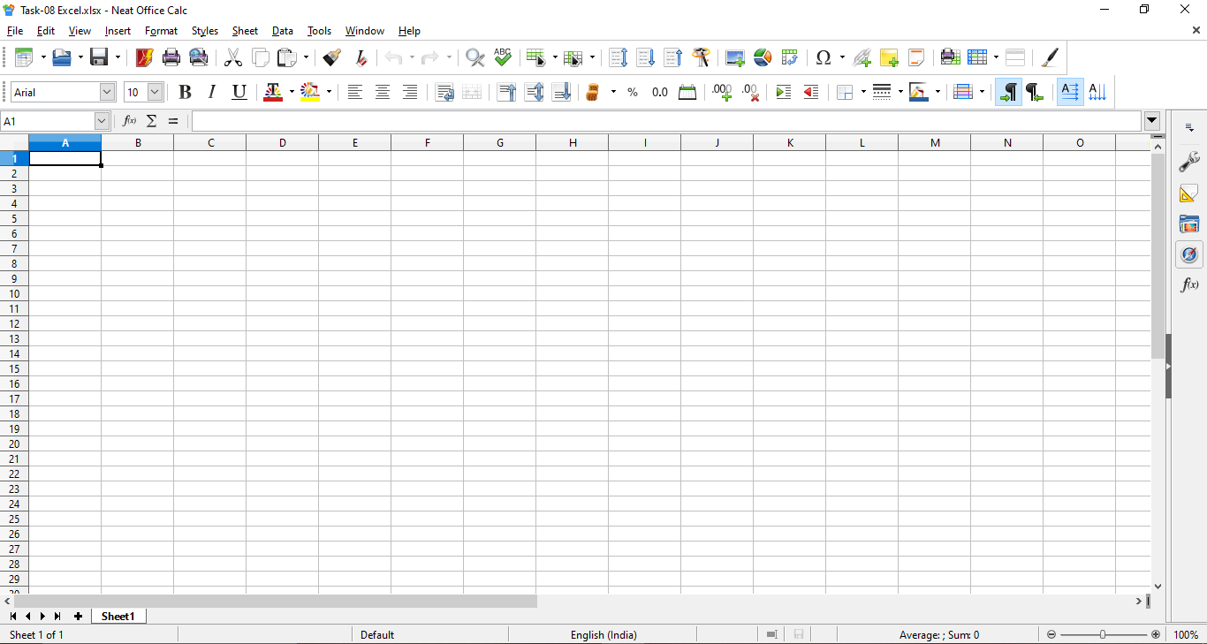

**Q3.Write the following data on the sheet.**

Column header:Name:Age:Email.

Row 1:John Doe,30,john@test.com

Row 2:Jane Doe,28,john@test.com

Row 3:Bob Smith,35,jacky@example.com

Row 4:Swapnil,37,swapnil@example.com

code:

package task_8;

import java.io.FileNotFoundException;

import java.io.FileOutputStream;

import java.io.IOException;

import org.apache.poi.xssf.usermodel.XSSFCell;

import org.apache.poi.xssf.usermodel.XSSFRow;

import org.apache.poi.xssf.usermodel.XSSFSheet;

import org.apache.poi.xssf.usermodel.XSSFWorkbook;

public class FileOperation {

public static void main(String[] args) throws IOException {

// Creating an object of file

try (XSSFWorkbook wb = new XSSFWorkbook()) {

try {

// Create a excel file with specified location

FileOutputStream file=new FileOutputStream("C:\\Users\\ELCOT\\eclipse-workspace\\guvi_tasks\\src\\task_8\\Task-08 Excel.xlsx");

System.out.println("File workbook successfully created");

// Create a Sheet in excel name of "Sheet1"

XSSFSheet sheet1=wb.createSheet("Sheet1");

System.out.println("Sheet has been created successfully");

Object[][] data= {

{"Name","Age","Email"},

{"John Doe","30","john@test.com"},

{"Jane Doe","28","john@test.com"},

{"Bob Smith","35","jacky@example.com"},

{"Swapnil","37","[swapnil@example.com](mailto:swapnil@example.com)"}};

int rowNum=0;

for (Object[] rowdata:data) {

// Creating a new row in the sheet

XSSFRow row=sheet1.createRow(rowNum++);

int colNum=0;

for (Object field:rowdata) {

// This line create a cell in the next column of the row

XSSFCell cell=row.createCell(colNum++);

if (field instanceof String) {

cell.setCellValue((String)field);

} else if (field instanceof Integer) {

cell.setCellValue((Integer)field);

}

}

}

System.out.println("Data added successfully");

wb.write(file);

} catch (FileNotFoundException e) {

e.printStackTrace();

}

}

}

}

**code and output:**

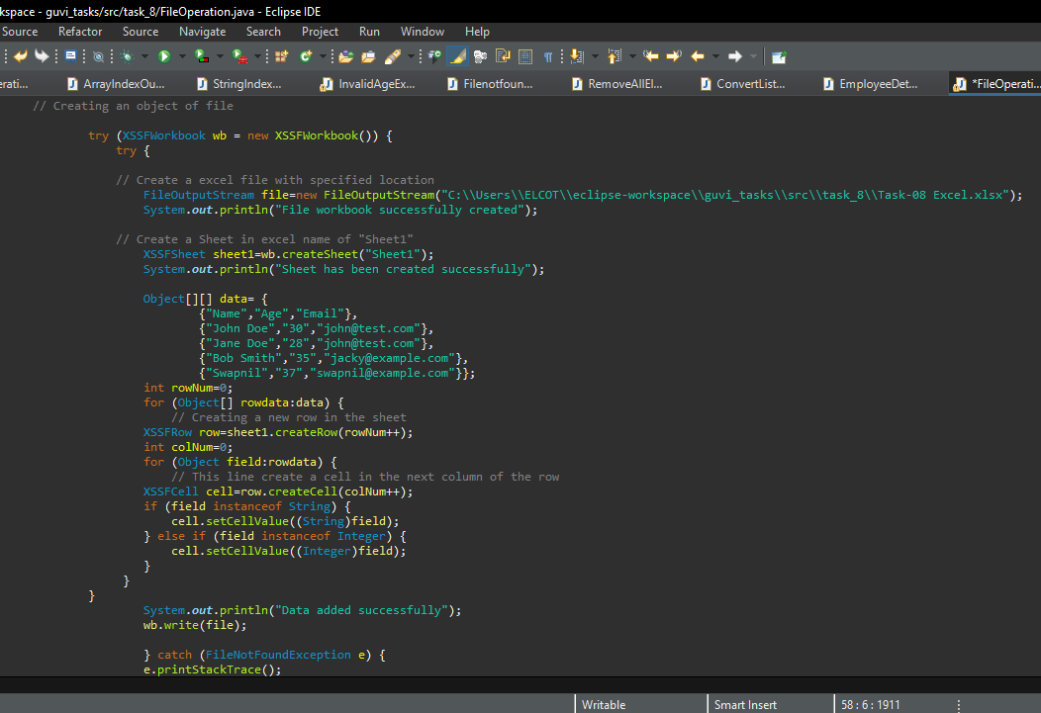

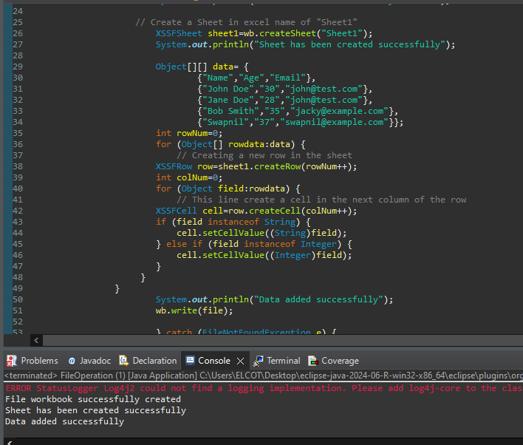

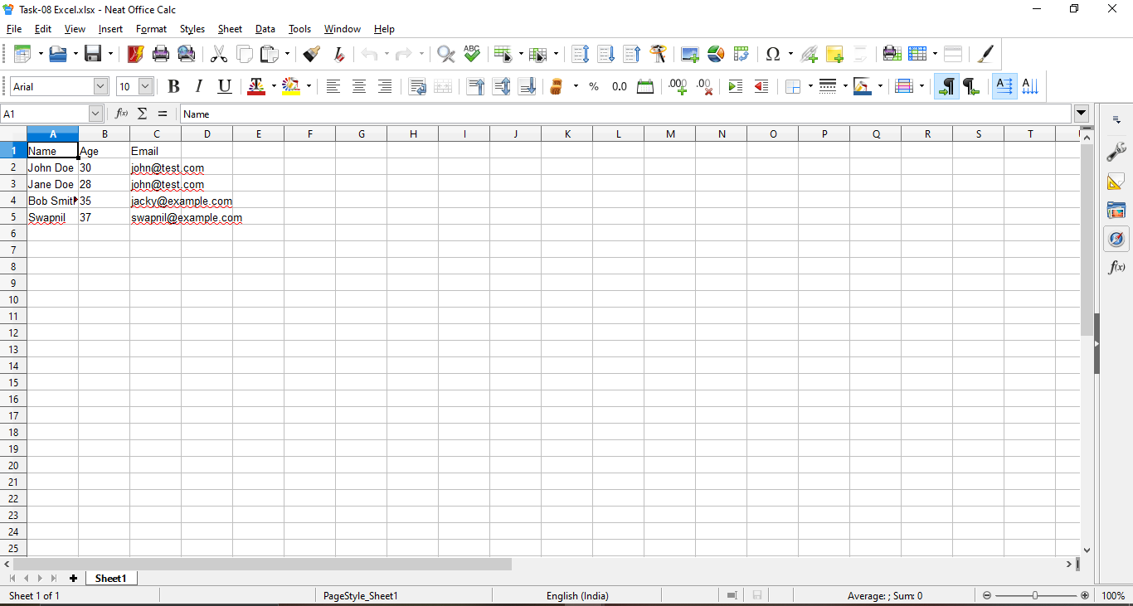

**Q4,5.Write a Java program to write data to an Excel file and read data from Excel file using the apache poi library**

Column header:Name:Age:Email.

Row 1:John Doe,30,john@test.com

Row 2:Jane Doe,28,john@test.com

Row 3:Bob Smith,35,jacky@example.com

Row 4:Swapnil,37,swapnil@example.com

code:

package com.task_8_FileOperation;

import java.io.FileNotFoundException;

import java.io.FileOutputStream;

import java.io.IOException;

import org.apache.poi.xssf.usermodel.XSSFCell;

import org.apache.poi.xssf.usermodel.XSSFRow;

import org.apache.poi.xssf.usermodel.XSSFSheet;

import org.apache.poi.xssf.usermodel.XSSFWorkbook;

public class FileOperation {

public static void main(String[] args) throws IOException {

// Creating an object of file

XSSFWorkbook wb=new XSSFWorkbook();

try {

// Create a excel file with specified location

FileOutputStream file=new FileOutputStream("C:\\Users\\ELCOT\\eclipse-workspace\\javaproject\\src\\com\\task_8_FileOperation\\Task-8 Excel.xlsx");

System.out.println("File workbook successfully created");

// Create a Sheet in excel name of "Sheet1"

XSSFSheet sheet1=wb.createSheet("Sheet1");

System.out.println("Sheet has been created successfully");

Object[][] data= {

{"Name","Age","Email"},

{"John Doe","30","john@test.com"},

{"Jane Doe","28","john@test.com"},

{"Bob Smith","35","jacky@example.com"},

{"Swapnil","37","swapnil@example.com"}};

int rowNum=0;

for (Object[] rowdata:data) {

// Creating a new row in the sheet

XSSFRow row=sheet1.createRow(rowNum++);

int colNum=0;

for (Object field:rowdata) {

// This line create a cell in the next column of the row

XSSFCell cell=row.createCell(colNum++);

if (field instanceof String) {

cell.setCellValue((String)field);

} else if (field instanceof Integer) {

cell.setCellValue((Integer)field);

}

}

}

System.out.println("Data added successfully");

wb.write(file);

} catch (FileNotFoundException e) {

e.printStackTrace();

}

}

}

**code and output:**

